Preventative Maintenance (PM) Guide in Repair Order Maintenance (ROM):

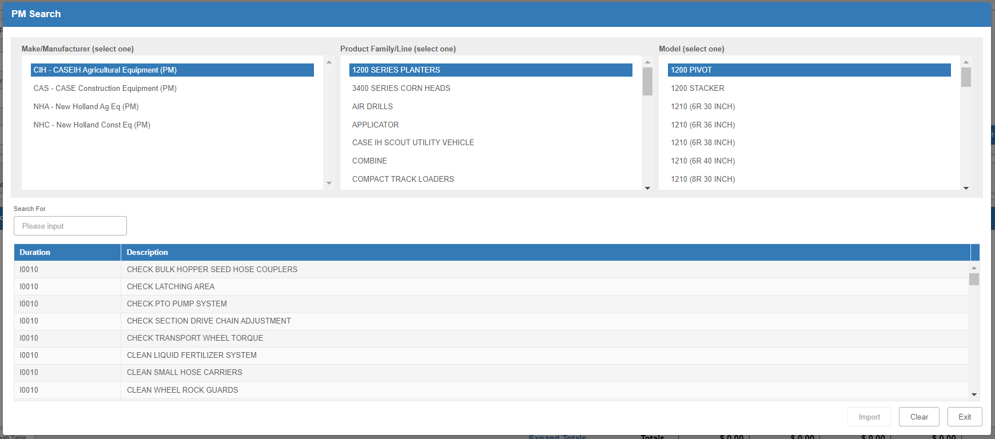

Preventative Maintenance (PM) tasks are pre-built by OEMs/manufacturers for their specific vehicles/units. The guides are made available to dealers through HBS Systems for use in their Service departments. There are 2 types of maintenance task – Initial and Recurring. The PM tasks are named by the first letter of these types followed by the number of hours when the PM is required. These tasks are retrievable by Make, Product Line/Family, and Model #.

PM Guide Search: To look up what PM tasks are available in your system, click the “PM Guide” button on the main ROM screen to view the search:

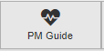

The initial Search screen will look similar to this:

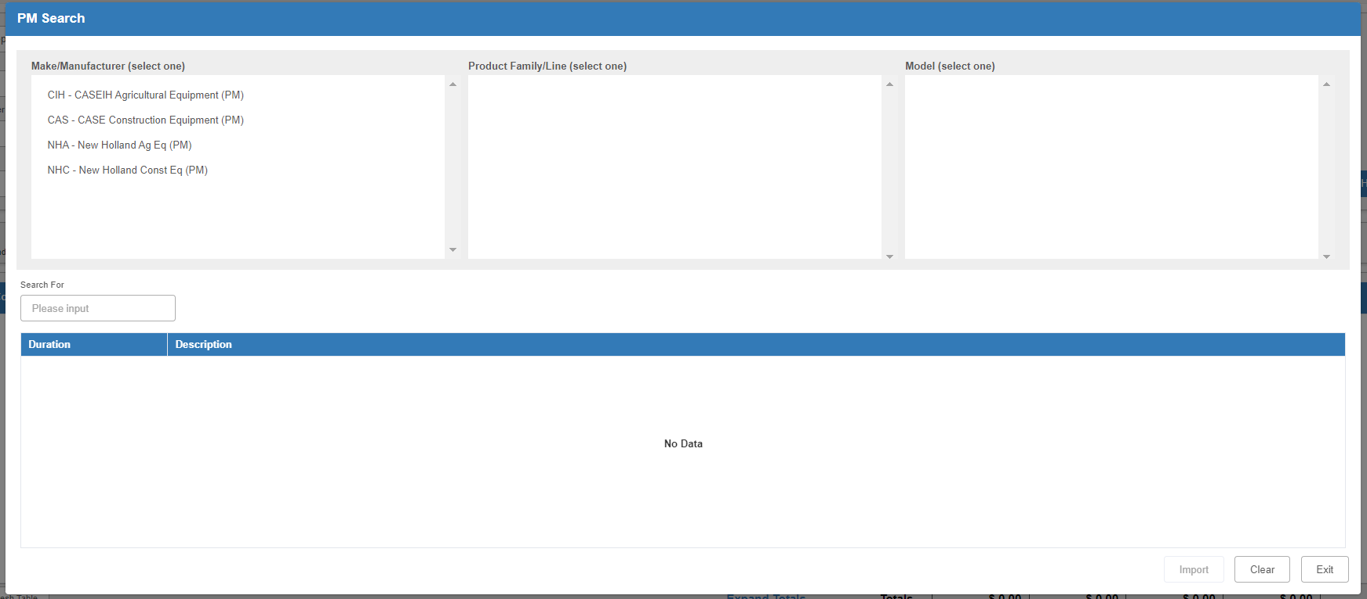

Select the manufacturer, product family/line, and model number whose tasks you wish to look at. The next selection will fill in as you click on each item.



After you pick the model number, you will see the list of tasks. You can filter the list using the Filter field just above the grid. All tasks with the same duration designation belong to the same PM job, and thus would be imported onto a repair order together.

Click Clear to reset the search. Click Exit to close the screen.

Importing a PM into an RO: To import a PM into a repair order, start by adding a new condition to the RO.

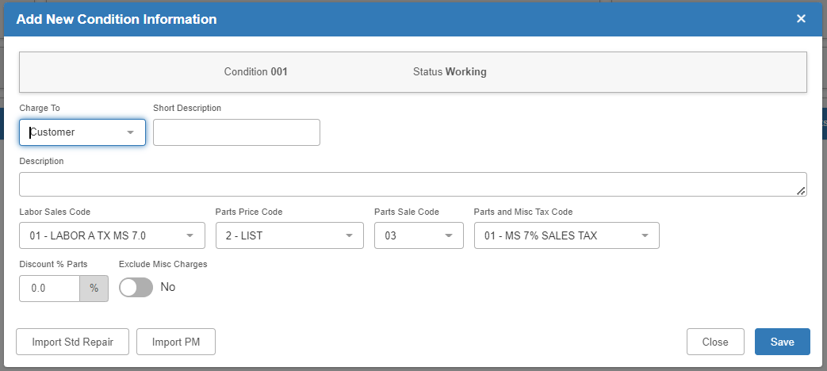

In the “Add New Condition Information” screen, click on Import PM to open the PM Guide Search.

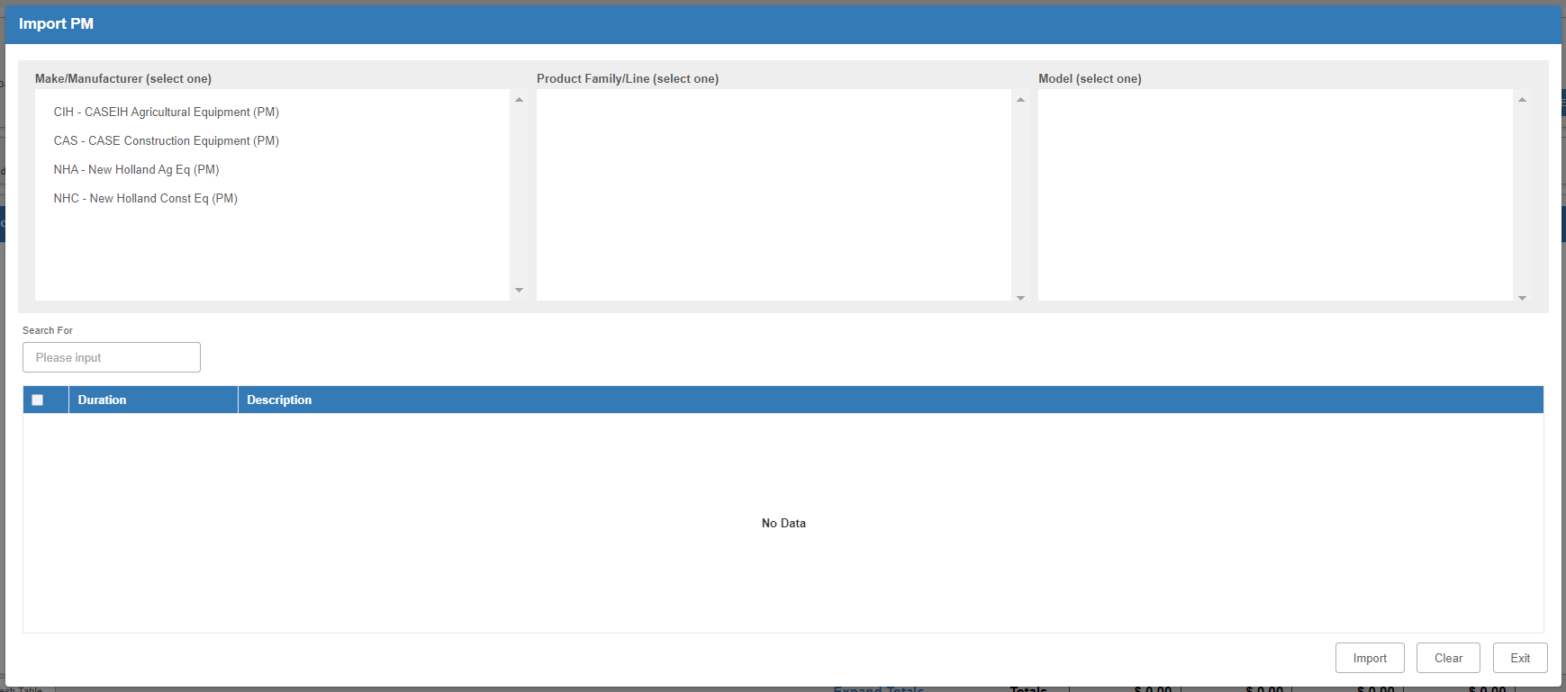

Select the make/manufacturer, product line/family and model number.

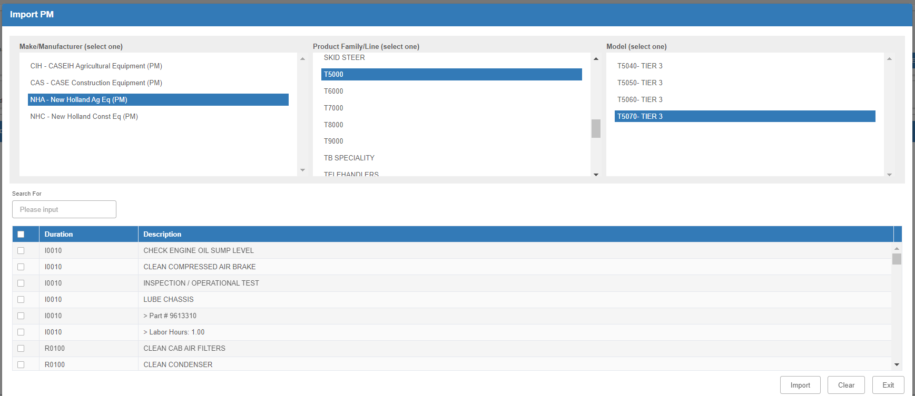

Choose the PM tasks from the list available. If you click on one element of a PM, it will select all portions of that PM.

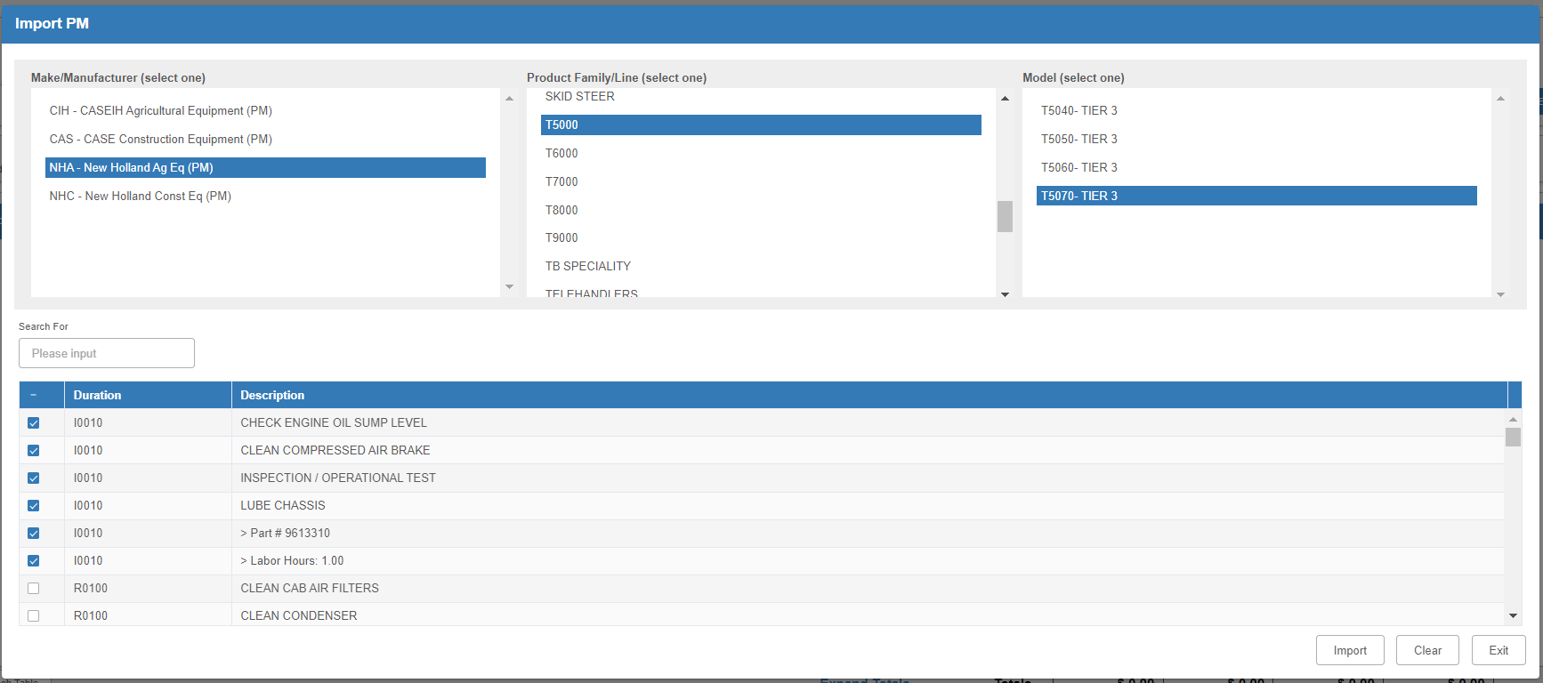

Once you have selected the PM(s), click the Import button at the bottom of the screen to pull them into the repair order.

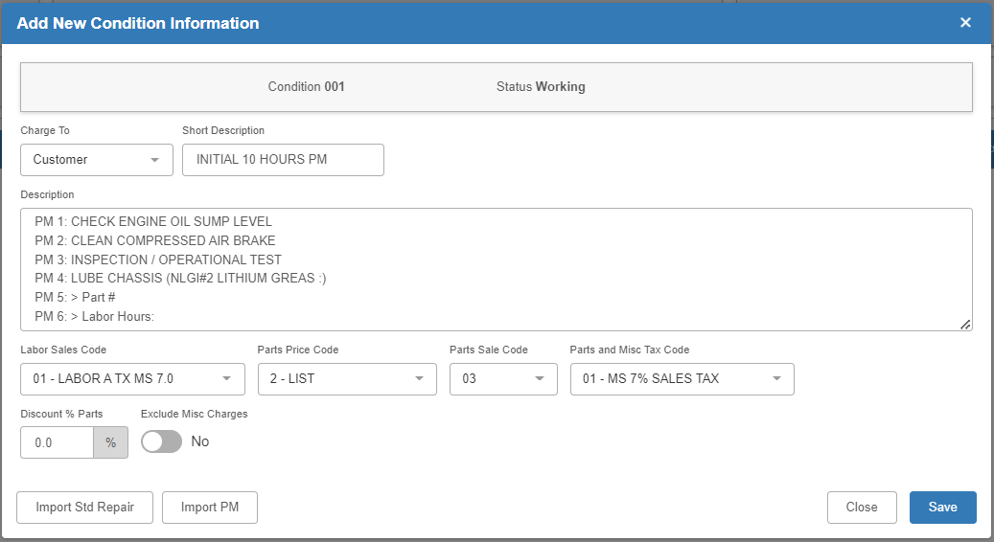

Save the condition. If there is a labor flat rate included in the imported tasks, the Maintenance OP Code screen will pre-fill the “Flat Rate Hours” field when it appears to prompt you to add the needed Labor code. NOTE: You will still have to manually add your Labor code.

After you create the condition, a Labor OP code with a flat rate from a PM task will look like this in the Maintenance OP Code screen:

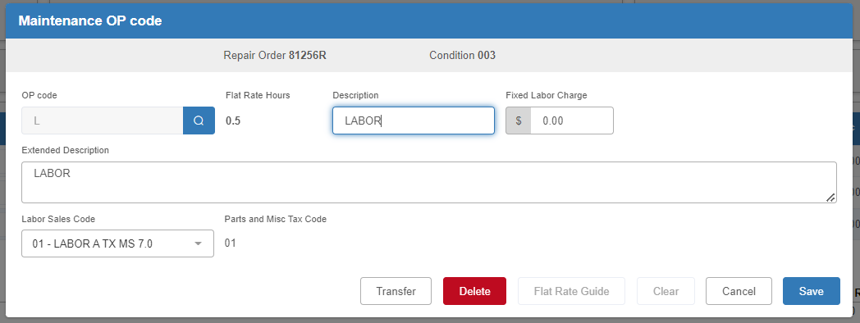

If there are any parts included in the PM tasks, you will need to open the Parts section of the condition. If you do not have a salesperson database, you will need to enter the Salesperson initials, at which point the Parts screen will automatically add the part(s) from the PM task. If you have a salesperson database, a salesperson will already be selected by default (though you can change the specific salesperson as needed). The part will therefore automatically add when you open the screen:

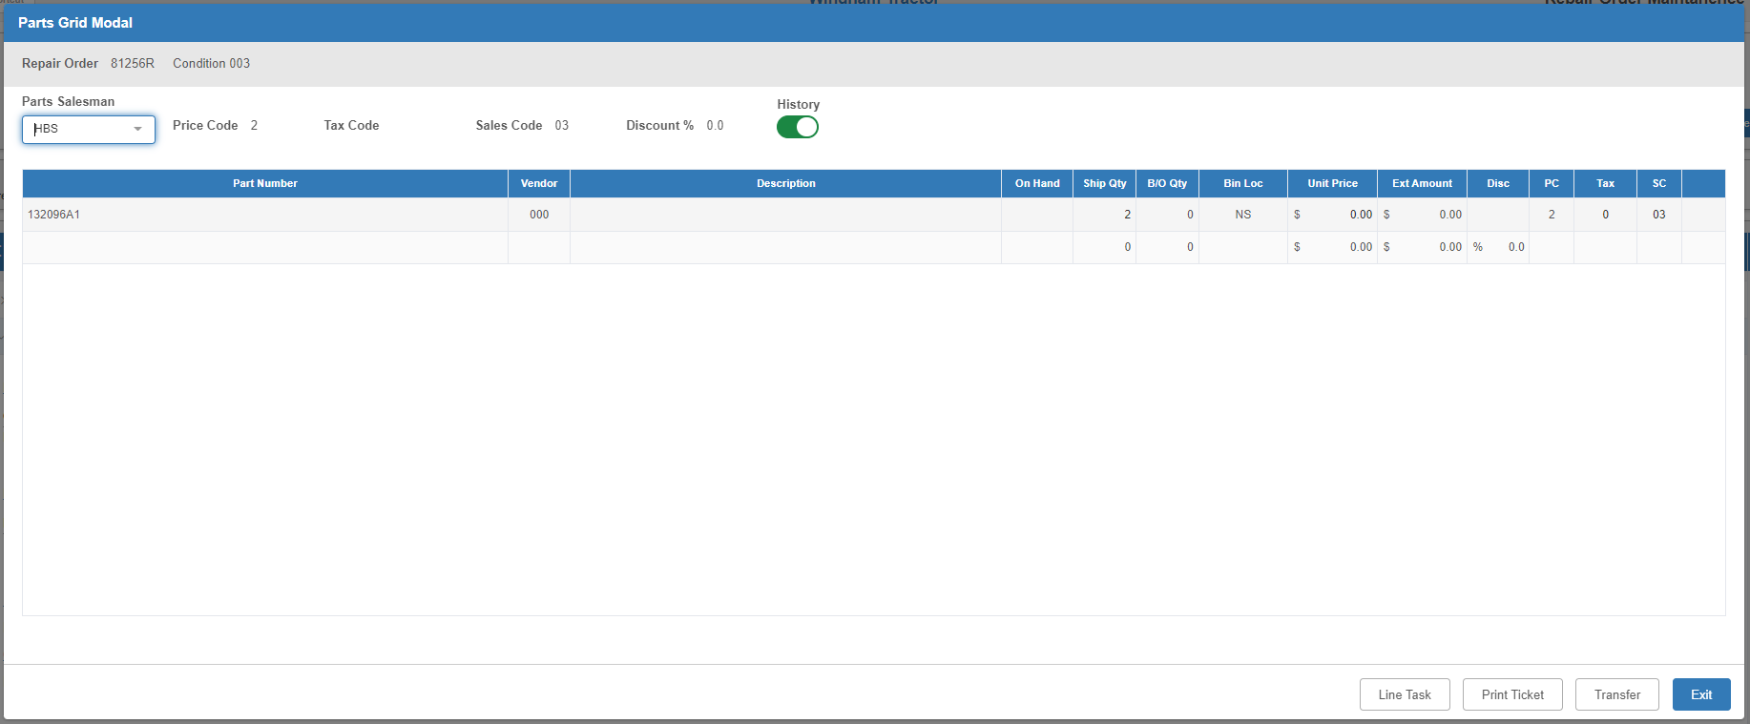

If you do not have the part in inventory, you will be prompted to either order the needed quantity of the part (if you just don’t have sufficient on-hand) or add the part to your inventory (if it does not currently exist in your system).

